

Insert School Logo

Semester One

Task 2 Test 2023

Question/Answer booklet

CHEMISTRY
UNIT 1

Name: __________________________________________________________________________________________

Teacher: _______________________________________________________________________________________

TIME ALLOWED FOR THIS PAPER

Reading time before commencing work: Five minutes
Working time for the paper: Forty-five minutes

MATERIALS REQUIRED/RECOMMENDED FOR THIS PAPER

To be provided by the supervisor:
This Question/Answer Booklet
Chemistry Data Book

To be provided by the candidate:
Standard items: pens, pencils, eraser or correction fluid, ruler, highlighter.

Special items: calculators satisfying the conditions set by the SCSA for this subject.

IMPORTANT NOTE TO CANDIDATES
No other items may be taken into the examination room. It is your responsibility to ensure that you do not have any unauthorised notes or other items of a non-personal nature in the examination room. If you have any unauthorised material with you, hand it to the supervisor before reading any further.
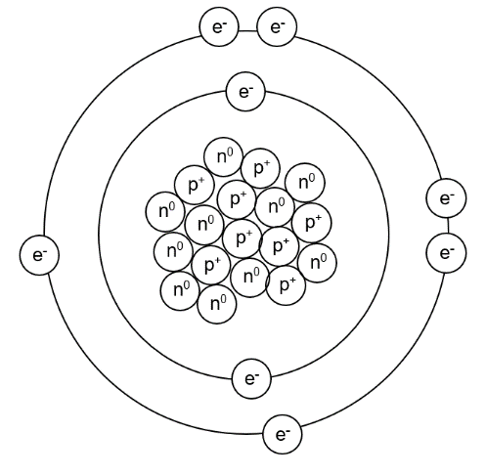
- Use your knowledge of the atom to complete the table below. [3 marks]
Sub-atomic  particle label | Sub-atomic  particle name | Sub-atomic  particle charge | Sub-atomic  particle weight
e⁻
p⁺
n⁰

- What is the name and symbol of the element in the model? [1 mark]

- What is the electron configuration of this element? [1 mark]

- What would be the electron configuration of this element if it was ionised to have a -2 charge? [1 mark]

- Complete the following table. [5 marks]
Symbol | Number of protons | Number of neutrons | Electron configuration
Mg²⁺  24  12 | 12
 |  | 0 | 1
S²⁻ |  | 17
Ar  33  12  40  18 |  |  | 2, 8, 8
 |  | 16 | 2, 8, 5

- Use the information provided to write a correct symbol for each of the following descriptions. [5 marks]
- The element that is in group 2 and period 4.

- A noble gas with exactly 3 occupied electron shells.

- An element from group 14 that is a non-metal.

- The element in period 3 that has the largest atomic radius.

- The element in group 16 that has the highest electronegativity.

- The isotopes of an element are different atoms that have a different number of neutrons. List one thing that isotopes share and one thing that isotopes have different in regards to their properties. [2 marks]

- Explain why the relative molecular mass of each element is not identical to those found on the periodic table. [2 marks]

- Silver atoms consist of 51.4% of the isotope ¹⁰⁷Ag and 48.6% of the isotope ¹⁰⁹Ag
Calculate the relative atomic mass of silver, rounding your answer to 1 decimal place. [3 marks]

- To determine isotope distributions, a mass spectrometer can be used. A mass spectrometer works in four different phases – ionization, acceleration, deflection, and detection. Describe the first three phases below, explaining why we require each step.
  - Ionization [2 marks]

  - Acceleration [2 marks]

  - Deflection [2 marks]

- Bohr based his model of the atom on hydrogen, noticing that when heated it emitted coloured light of specific wavelengths. Explain why this occurs. [4 marks]

- Atomic Absorption Spectroscopy (AAS) can be used to detect incredibly low amounts of various heavy metals. Explain how AAS is different to a typical flame test. [2 marks]

- At a particular crime scene, a man was found murdered at his kitchen table. Suspected to have died of lead poisoning, a forensic scientist decided to use AAS to construct a calibration curve, shown below

- Name the type of hallow cathode lamp the scientist would have used and explain why this specific one is needed. [2 marks]

- The lab results indicated that the water the man drank from had an absorbance reading of 0.35. What was the concentration of lead in the drinking water? [1 mark]

- The NHMRC has a limit of 0.01 mg/L concentration of lead, with anything above this being considered toxic to humans. Determine whether the man was likely to have died from lead poisoning, explaining why. [2 marks]

- Describe and explain the trends in electronegativity down the group and across a period in the periodic table. [5 marks]

